Class: SYMCA Div: B  Semester: III | Course Code: MCA01604  Course Name: Data Science Laboratory |  | Batch: S2
Name: Ajit Bajarang Mali |  | Roll No: 52140
CO No: CO605.2 |  | Assignment No: 07
PRACTICAL SUBMISSION RECORD- A.Y. 2024-25

Title: Using grocery dataset with minimum support to 0.001 and minimum confidence of 0.8 build a Frequent Pattern Tree (FP-Tree). Show for each transaction how the tree evolves

Code:

# --- Step 1: Import necessary libraries ---
import pandas as pd
from mlxtend.preprocessing import TransactionEncoder
from mlxtend.frequent_patterns import fpgrowth, association_rules
from tabulate import tabulate

# --- Step 2: Data Loading and Preparation ---
filename = 'groceries.csv'
dataset = []
try:
df = pd.read_csv(filename)

df = df.drop(columns=df.columns[0])

for index, row in df.iterrows():
transaction = row.dropna().tolist()
dataset.append(transaction)

except FileNotFoundError:
print(f"Error: '{filename}' not found. Please make sure the file is in the same directory as the script.")
exit()
except Exception as e:
print(f"An error occurred: {e}")
exit()

te = TransactionEncoder()
te_ary = te.fit(dataset).transform(dataset)
df_encoded = pd.DataFrame(te_ary, columns=te.columns_)

# --- Step 3: Apply the FP-Growth algorithm with your specified support ---
min_support_threshold = 0.01
frequent_itemsets = fpgrowth(df_encoded, min_support=min_support_threshold, use_colnames=True)

# --- Step 4: Generate association rules with your specified confidence ---
min_confidence_threshold = 0.5
rules = association_rules(frequent_itemsets, metric="confidence", min_threshold=min_confidence_threshold)

# --- Step 5: Display Output ---
print("\n" + "="*80)
print(" " * 20 + "FP-GROWTH ANALYSIS RESULTS")
print("="*80 + "\n")

# --- Frequent Itemsets ---
print(f"Top 15 Frequent Itemsets (Support >= {min_support_threshold})")
sorted_itemsets = frequent_itemsets.sort_values(by='support', ascending=False)
print(tabulate(sorted_itemsets.head(15), headers='keys', tablefmt='psql', showindex=False))
print(f"\n[INFO] Found a total of {len(frequent_itemsets)} frequent itemsets.\n")

# --- Association Rules ---
print(f"Generated Association Rules (Confidence >= {min_confidence_threshold})")
if rules.empty:
print("No rules found for the given support and confidence thresholds.")
else:
relevant_rules = rules[['antecedents', 'consequents', 'support', 'confidence', 'lift']]
sorted_rules = relevant_rules.sort_values(by=['confidence', 'lift'], ascending=False)
print(tabulate(sorted_rules.head(15), headers='keys', tablefmt='psql', showindex=False, floatfmt=".4f"))
print(f"\n[INFO] Found a total of {len(rules)} rules.\n")

Output:

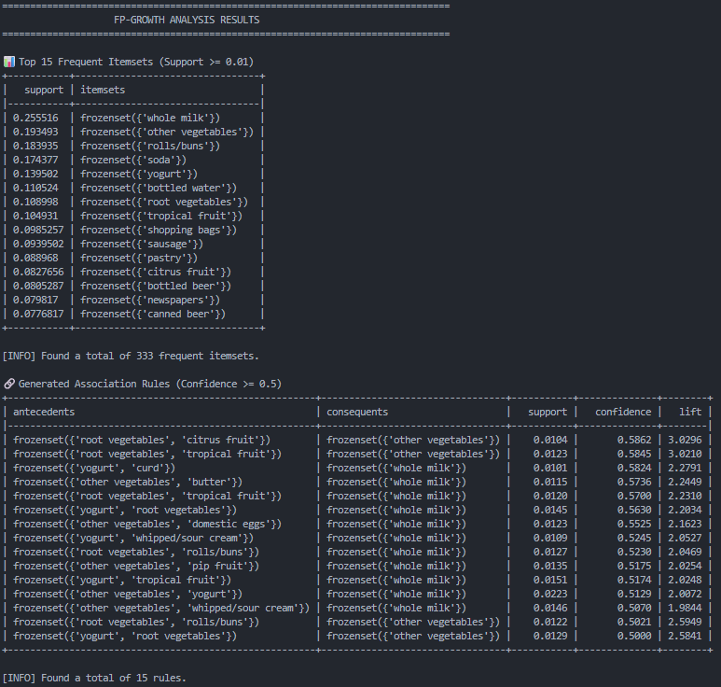

Each transaction how the tree evolves
- Calculate Item Frequency & Establish Order
- bread: 5
- milk: 4
- butter: 4
- sugar: 2
- eggs: 2
- coffee: 1 (Discarded as its count is less than 2)
- Building the FP-Tree Transaction by Transaction

Transaction 1:

Tree State:
(root)
└── bread:1
└── butter:1
└── milk:1

Transaction 2:

Tree State:
(root)
└── bread:2
├── butter:1
│ └── milk:1
└── milk:1
└── sugar:1

Transaction 3:

Tree State:
(root)
├── bread:2
│ ├── butter:1
│ │ └── milk:1
│ └── milk:1
│ └── sugar:1
└── butter:1
└── milk:1
└── eggs:1

Transaction 4:

Tree State:
(root)
├── bread:3
│ ├── butter:2
│ │ ├── milk:1
│ │ └── eggs:1
│ └── milk:1
│ └── sugar:1
└── butter:1
└── milk:1
└── eggs:1

Transaction 5:

Tree State:
(root)
├── bread:4
│ ├── butter:3
│ │ ├── milk:2
│ │ │ └── sugar:1
│ │ └── eggs:1
│ └── milk:1
│ └── sugar:1
└── butter:1
└── milk:1
└── eggs:1

- FP-Tree Structure

Final Tree:
(root)
├── bread:5
│ ├── butter:3
│ │ ├── milk:2
│ │ │ └── sugar:1
│ │ └── eggs:1
│ └── milk:1
│ └── sugar:1
└── butter:1
└── milk:1
└── eggs:1

